

**Society of Saint Vincent de Paul**

***Ontario Regional Council***

BN876642703 RR0001

www.ssvp.on.ca

**Fall Assembly 2024** - **Members Registration**

Hotel: Visitors Inn 649 Main Street West, Hamilton 905-529-6979

Hotel: C Hotel 1530 Stonechurch Rd., East, Hamilton 905-381-9898

Events Location: **Annunciation of Our Lord Church/Parish Centre,**

**280 Limeridge Road West, HAMILTON, ON**

|  |  |  |
| --- | --- | --- |
| **Full Name:** | | **Position:** |
| **Conference/Council:** | | |
| **Phone:** | **Email:** | |
| **Special Dietary Needs?** | | |

**Friday, October 4, 2024**

|  |
| --- |
| Will you be visiting the Hamilton Stores? Bus leaves from Annunciation Centre@1:00 – 3:00 pm? YES? NO? ….. |
| Do you plan on attending the Meet and Greet: 6:00 – 9:00 p.m. at Annunciation Centre? YES? NO? ………. |

**Saturday, October 5, 2024**

Please indicate which workshop you will attend: Choose one from each session **(BOLD your “YES”)**

|  |
| --- |
| **Workshop Session I -- 11:00 – 11:45 a.m.** |
| A. Essential to Serving in Hope – Rejuvenation (Linda Alexander, Pat Lenz) - YES |
| B. Navigating Difficult Conversations – Stores Regional Committee (Justin Smith) - YES |
| C. The Joys of Our Twins – Twinning (Lori Stewart, Guido Kelly) - YES |

|  |
| --- |
| **Workshop Session II -- 1:15 – 2:00 p.m.** |
| A. How to help with collecting food for Nunavut - North of SIXTY (Michael Wasney, Marg Lafontaine) - YES |
| B. Serving in Hope in our Multicultural Canadian Society – MCDC (Omar Ellis, Guido Kelly) - YES |
| C. Assisting our Neighbours on how to use available Resources – Seeds of Hope (Linda Alexander) - YES |

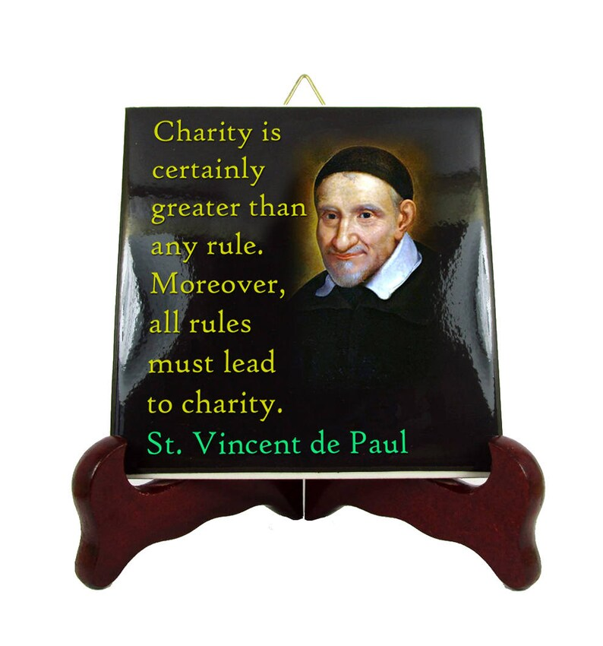Please download/scan/complete this form and email it to lerouxp05@gmail.com ASAP or before October 1, 2024 to help us with the planning and coordination of this event. Register early for the BUS TRIP to the stores as seats are limited.