

**Society of Saint Vincent de Paul**

***Ontario Regional Council***

BN876642703 RR0001

**Fall Assembly 2025 – Oct 3rd & 4th**

**Members Registration Form**

|  |  |
| --- | --- |
| **Hotel:** | **Comfort Inn Newmarket**  1230 Journey’s End Circle, Newmarket, ON, L3Y 8Z6 Tel: (905) 895-3355  **Please Book** as soon as possible. |
| **Event Location:** | **St. John Chrysostom / St Elizabeth Seton Church - York Simcoe PC**  17955 Leslie Street, Newmarket, ON L3Y 9A4 |
| **Theme:** | **“SERVING in HOPE thru SIMPLICITY and SELFLESSNESS”** |

|  |  |  |
| --- | --- | --- |
| **Full Name:** | | **Position:** |
| **Conference/Council:** | | |
| **Phone:** | **Email:** | |
| **Special Dietary Needs?** | | |

**Friday, October 3, 2025**

|  |  |
| --- | --- |
|  | **Y-Yes / N-No** |
| Will you be visiting the **’Rose of Sharon’** Tour? Car Pool from Hotel @ 2:30pm - 4:00 pm? |  |
| Do you plan on attending the Meet and Greet: 6:00 – 8:00 p.m. at Church Hall? |  |

**Saturday, October 4, 2025**

All Participants are required for *Townhall Workshop Session I*

|  |  |
| --- | --- |
| **Townhall Workshop Session I -- 11:00 – 11:45 a.m.** | **Y - ‘YES’** |
| **A Vincentian look at Sainthood** – ONRC Spiritual Advisor *(Deacon John Girolami)* | **Y** |

Please choose one workshop from *Workshop Session II* by typing **Y - ‘YES’**

|  |  |
| --- | --- |
| **Classroom Workshop Session II -- 1:00 p.m. – 1:45 p.m.** | **Y -‘YES’** |
| **A)** **Practicing Vincentian Simplicity (Honesty)** - ONRC MCDC *(Omar Ellis – Co-Chair)* |  |
| **B) Service & Selflessness : The St Vincent De Paul Journey** – ONRC MCDC *(Guido Kelly - Co-Chair)* |  |

Please download/scan/complete this form and email it to [events@ssvp.on.ca](mailto:events@ssvp.on.ca) before September 30, 2025.

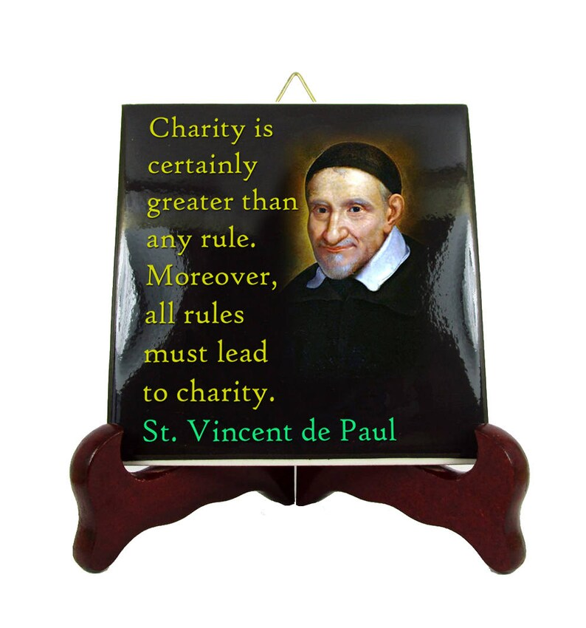Register early for the SSVP TOUR to the ’Rose of Sharon’ as seats are limited.

Thank you for registering early and we look forward to seeing you in Newmarket.